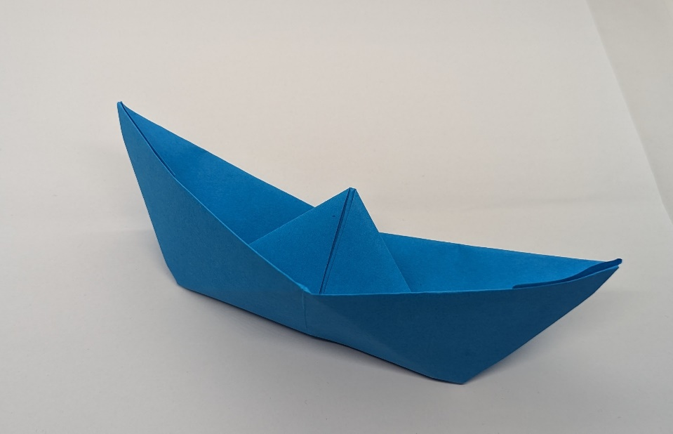**Sailboat** April 2024

**Traditional Model**

**Written by Rochelle Mazze.**

**Proofreading by Agustina Pildain.**

**Based on the verbal diagram of Michel Lucas.**

**Advanced Beginner**

Some form of this model was in existence over 500 years ago. The model begins as a “sailors hat” and then transforms into a boat. With thick enough paper, it will float in a tub! Finished, the three-dimensional model has an oblong boat shape with room for a very small passenger. The base can be slightly rounded so the model will sit upright. The triangular center represents the boat’s sails.

**Method of folding—**the model is folded with a number of pre-creases which facilitate opening to change its shape. The pre-creases are given as reverse folds. For example, the instruction can be to make a valley fold. Then reverse this to a mountain fold. Or, turn the paper over and valley fold again, essentially reversing the fold. The model uses rectangular paper of any size. Colored copy paper will have a heavier weight than standard printer paper and will make a sturdier model.

**Step 1.** Place the paper rectangle on a table with the short edge closest to you, portrait orientation.

**Step 2.** Valley fold the near edge to the far edge. Crease firmly.

**Step 3.** Rotate the model 180 degrees so that the two single short edges are near to you and the folded edge is on the far side.

**Step 4.** Valley fold the model in half by bringing the right edge over to meet the left edge. Crease firmly and unfold. Reverse this fold to a mountain fold. Crease firmly. Do not unfold.

The model is now a *rectangle* of 4 layers of paper. Orient the model so the long left side has a single folded edge. There are 4 single edges on the right side. The short side of the rectangle, made of 4 single edges are on the side closest to you. There are two folded edges on the top.

**Step 5.** Find the two folded edges (layers) on top of the model**.** Each layer has two sides. Take the right corner (of the top layer only) *and fold as much as possible to the left side*, creating a new triangle. When completed, the folded side of this new triangle will be aligned with long left folded edge.Crease firmly.

**Step 6.** Flip the top layer to the left and flatten. All the surfaces facing up are smooth.

**Step 7.** Turn the model over. The triangular flap is now on the right side. The open flaps are parallel to you on the bottom.

**Step 8.** Thisstep is similar to step 5. Take the top corner on the left side of the model and make a valley fold so that its folded edge will align with the folded edge of the triangle at the center. The model now has two triangles on the surface, with folded edges meeting at the center vertical crease. There is a long horizontal rectangle below the triangles. This rectangle has both a top and a bottom layer.

**Step 9.** Valley fold the bottom rectangle of the model, top layer only, bringing it up as far as it will go. Crease firmly. The rectangle will now cover the bottom edges of the triangles.

**Step 10.** Find the right corner of the rectangle you just folded. Mountain fold this corner, wrapping it behind the folded edge of the triangle.

**Step 11.** Repeat this fold with the left corner of the rectangle.

**Step 12.** Turn model over. The shape of the model is triangular with smooth side facing up. The base long edge is parallel to you. At the base of either side of the large triangle are two triangular flaps.

**Step 13.** Valley fold the bottom edge of the model up as far as it will go. This new folded edge will align with the folded edge below it. The model now resembles a sailor’s hat.

**Step 14.** Valley fold the model in half so that the sloping folded edges align with each other. Crease firmly and unfold. There is now a vertical fold in the center of the model.

**Step 15.** Turn the model over. Valley fold the model in half again along the same vertical fold. This fold is now a mountain fold on the reverse side. Crease firmly and unfold.

**Step 16.** Pick the model up so that the split edges face the floor. Place the thumbs of both hands inside the model. Adjust the hand position so that the thumb of one hand is inside on the top layer of the model, with fingers on the surface, and the thumb of the other hand is on the inside of the lower layer with fingers on the outside of the model.

**Step 17.** Pull your hands apart flattening the model into a diamond shape. Crease firmly.

**Step 18**. Place the model on a table. Orient the model so the open points are nearest to you. If there are any raised triangular flaps near these bottom points, smooth them down to the opposite edge.

**Step 19.** Find the lowest point of the top layer of the model. Valley fold this corner up to almost meet the folded point on the top. Turn the model over. It will present as a diamond shape.

**Step 20.** Repeat the action in Step 19, valley folding the lowest corner to almost meet the top of the model. The model now resembles a triangle. The triangle has 3 layers. Crease firmly.

**Step 21.** Steps 21 and 22 have similar actions to Steps 17 and 18. Model is raised in the air, open edges facing the floor. Have the thumb of one hand inside the model with fingers aligned against the split vertical folded edges of one side of the model and the thumb of the other hand inside the model with fingers against the split vertical folded edges of the opposite side.

**Step 22.** Pull your hands apart flattening the model into a diamond shape. Crease firmly.

**Step 23.** Lift the model so that the split points face the floor. Place the left hand on the left side of the model and the right hand on the right side. On each side of the model, locate the vertical folded edges towards the top point. Firmly grasping these top points with the thumb and forefingers of each hand, pull your hands apart as far as they will go. This action will cause rectangular sides of the model to come up and form a boat shape. Flatten the model.

**Step 24.** Completion. The model is now a three-dimensional sailboat with a triangular center. The center can be adjusted so that the “sails” are perpendicular to the table. The underside of the boat can be rounded, using your fingers to widen this circular space, to allow the model to stand upright.